SET A

Output
true
34.0
6
4
4
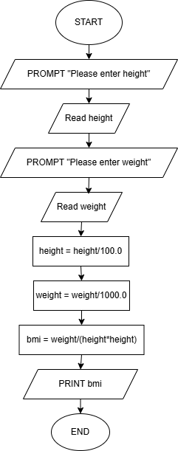

SET B

Output
-83.5
true
-1
-2
-4
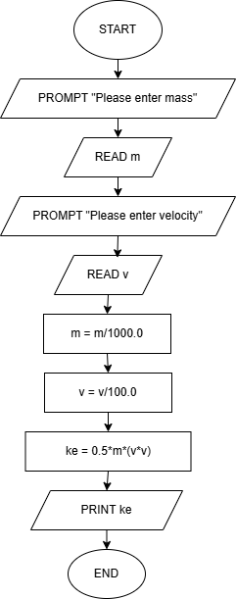

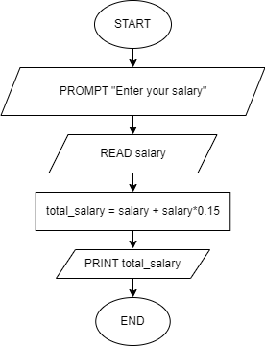

SET C

Output
-9
false
3
3
2

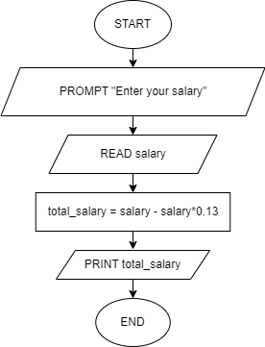
SET D

Output
-28
false
16.0
4
-9

